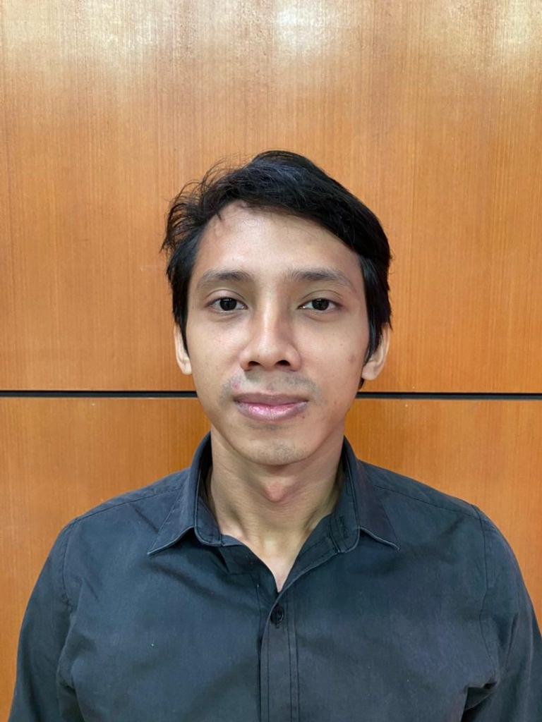 | MUHAMMED MUNIR BIN MOHD AZMI  Full-Stack Systems Engineer & IT Professional • Network Security (UTM)  📍 Puchong, Selangor | 📞 +60 13-563 6124 | ✉️ muhammed.munir97.mm@gmail.com  🌐 Portfolio: https://muhammedmunir.github.io/ | 🔗 LinkedIn: linkedin.com/in/muhammed-munir-bin-mohd-azmi-9b233b271 | 💻 GitHub: github.com/muhammedmunir

PROFESSIONAL SUMMARY
Versatile, security-conscious Full-Stack Systems Engineer with proven experience developing and maintaining high-reliability enterprise platforms, public sector asset management systems, and AI-driven automation applications. Highly skilled in Vue.js 3, Laravel 11/12 (Filament), SvelteKit, Flutter, Docker Swarm, and Python Computer Vision, backed by an academic background in Computer Science (Network Security) from UTM, industry Cisco networking certifications, and hands-on Security Operations Center (SOC) threat defense experience at Tenaga Nasional Berhad (TNB).
WORK EXPERIENCE
Programmer / Full-Stack Enterprise Developer — YHCM Sdn Bhd | Apr 2026 – Present
Shah Alam, Selangor
• Maintain & Upgrade Mission-Critical Systems: Support enterprise web applications for the public/government sector (including eMesys, Sutera, and ADIMS), complying with strict data security, role-based access control (RBAC), and audit standards.
• Modern Frontend & Admin Portals: Architect modular user interfaces utilizing Vue.js 3 and streamline operations using Laravel Filament admin panels.
• Database Architecture & Tuning: Optimize relational schemas, indexes, and complex queries across MySQL, MariaDB, and PostgreSQL 17.
• Containerization & Orchestration: Deploy, manage, and scale microservices and container workloads using Docker and Docker Swarm.
• Hybrid Infrastructure Administration: Administer, harden, and troubleshoot hybrid production servers across Linux (Ubuntu) and Windows Server environments.
• Tier-2/3 Technical Operations: Resolve operational IT incidents, configure secure enterprise API integrations, and support day-to-day organizational IT workflows.
IT Support & Web Developer — Nova Bitara Development Sdn Bhd | Dec 2025 – Mar 2026
Sunway, Selangor
• Collateralized Loan Platform (IWA001): Engineered and deployed a production loan management system using SvelteKit and Supabase PostgreSQL with strict Row Level Security (RLS) policies and JWT auth, hosted on Vercel.
• Trilingual Corporate Portal: Built corporate web portal (Infinity World) using SvelteKit, Redis caching, and Resend transactional email API.
• Commercial E-Commerce Platform: Developed e-commerce platform using Laravel and MySQL, deployed on DirectAdmin with Cloudflare WAF/CDN.
• Enterprise IT Operations: Delivered comprehensive internal IT support, troubleshooting corporate hardware, operating systems, network connectivity, and DNS infrastructure.
Enterprise Mobility Solutions (Protégé) — Tenaga Nasional Berhad (TNB) | Apr 2025 – Dec 2025
UOA Business Park, Shah Alam
• Full-Stack Mobile Development: Spearheaded full-stack development of Onboardx, an enterprise onboarding application utilizing Flutter (Dart) and JavaScript.
• Multi-Database Integration: Engineered multi-database architecture supporting Firebase Realtime DB, MongoDB, Supabase, and MySQL.
• Azure Cloud Administration: Configured and maintained Ubuntu cloud servers on Microsoft Azure, managing Network Security Groups (NSGs) and system resource monitoring.
• DevOps & CI/CD Pipelines: Automated build and delivery pipelines with Jenkins CI/CD and gained hands-on container orchestration experience with Kubernetes.
• UI/UX Design & Support: Designed user journeys in Figma; resolved technical user support tickets within strict SLA turnarounds.
Cyber Security Threat Defense (Internship) — Tenaga Nasional Berhad (TNB) | Sept 2023 – Feb 2024
Platinum Bangsar, Kuala Lumpur
• SOC Real-Time Threat Monitoring: Monitored enterprise network traffic and web access logs via Splunk SIEM dashboards in an active Security Operations Center.
• Red Team Vulnerability Analysis: Collaborated with the Red Team using Vulhub Docker environments to reproduce and evaluate known CVE exploits.
• Blue Team Defense Hardening: Assisted in security patch verification, log audits, system configuration hardening, and compliance alignment with ISO 27001 and NIST frameworks.
Information & Communication Technology (Internship) — Tenaga Nasional Berhad (TNB) | Dec 2019 – Feb 2020
Kota Bharu, Kelantan
• Fiber Optic Topography & Costing: Mapped regional fiber optic routes via Google Earth; calculated precision transmission distances and costing models in Excel.
• Network Infrastructure Audits: Assisted network engineers with signal attenuation testing, physical equipment audits, and preventive maintenance.
FEATURED SYSTEMS & ENGINEERING PROJECTS
TINDAK — AI-Powered Mobile Action Engine — Flutter, Dart, Supabase RLS, Gemini AI | Portfolio Showcase
• Android rapid-action utility intercepting Share Intents to parse URLs, contact details, and payments locally via a regex/rule engine with Gemini AI fallback and Supabase RLS backend.
9Router Office — Autonomous AI Agent 3D Workspace — Node.js 22+, Three.js, Model Context Protocol (MCP) | Portfolio Showcase
• Interactive 3D virtual office in Three.js where autonomous AI agents collaborate in real time using MCP SDK tools, voice synthesis, memory persistence, and Playwright MCP E2E automation.
Computer Vision & Win32 Desktop Automation Suite — Python, OpenCV, CustomTkinter, Win32 API | Portfolio Showcase
• Advanced desktop automation framework utilizing multi-scale SIFT pyramid matching, CIELAB color segmentation, closed-loop visual servoing, dynamic OCR, and multithreaded GUI.
Baby Kicking Suite — Mobile Maternal Health Tracker — Flutter, Dart, Firebase Firestore & Functions | Portfolio Showcase
• Cross-platform Flutter maternal wellness app enabling expectant mothers to track fetal movements with real-time Firebase sync, irregularity trend alerts, and structured clinical PDF export.
Lumina Glass Studio & Smart Mirror Visualizer — SvelteKit, Tailwind CSS, Laravel 11 RESTful API | Portfolio Showcase
• Interactive LED smart mirror configurator featuring Kelvin color temperature (3000K–6500K) controls, backed by Laravel 11 RESTful API with 100% PHPUnit feature test coverage.
TECHNICAL SKILLS
Frontend & Mobile: | Vue.js 3, SvelteKit, Flutter (Dart), React.js, Tailwind CSS, HTML5, CSS3, JavaScript (ES6+), TypeScript, Three.js
Backend & APIs: | Laravel 11/12 (PHP 8.2+), Laravel Filament, Node.js, Python, RESTful APIs, C#, C++, Java
Databases & Cloud: | PostgreSQL (RLS), MySQL, MariaDB, Supabase, Firebase (Firestore & Realtime DB), MongoDB, Redis, Microsoft Azure, Vercel
DevOps & Security: | Docker, Docker Swarm, Jenkins, Kubernetes (Basic), Git / GitHub, Cloudflare WAF/CDN, DirectAdmin, Splunk SIEM, Wireshark, Vulhub, Firewall & VPN, ISO 27001, NIST
AI, Systems & Tools: | Model Context Protocol (MCP), OpenCV, Gemini AI, Playwright, Linux (Ubuntu, Kali), Windows Server, Figma, Microsoft Power BI
EDUCATION & CERTIFICATIONS
Bachelor of Computer Science (Network Security) — Universiti Teknologi Malaysia (UTM) | 2021 – 2024 | CGPA: 3.17
Johor Bahru, Johor
• Final Year Project: Geospatial Reporting Management System for UTM (SvelteKit, Tailwind CSS, Google Maps API, Supabase).
• Key Coursework: Ethical Hacking & Penetration Testing, Cybersecurity Governance & Compliance, Network Security.
Diploma in Computer Science — Universiti Teknologi Malaysia (UTM) | 2017 – 2020 | CGPA: 2.72
Kuala Lumpur
• Final Year Project: E-Commerce Web Platform with user authentication, catalog management, and payment flows (PHP, MySQL, Azure).
• Key Coursework: Object-Oriented Programming (C#), Structured Programming (C++), Java Programming.
• Cisco Certifications: CCNAv7: Introduction to Networks • CCNAv7: Switching, Routing & Wireless Essentials • Cisco DevNet Associate • Cisco Network Security • IoT Fundamentals: Connecting Things
• Specialized Analytics: Microsoft Power BI Data Analysis (Jan 2025) • Python for Data Analysis (Dec 2024)
LANGUAGES
Malay: Native / Bilingual Proficiency | English: Professional Working Proficiency

